Market Monitor - Afghanistan - 2026-08

Highlights
The cost of staple foods in Afghanistan saw a slight monthly increase, continuing a year-long inflationary trend. Regional price variations were significant, with some provinces experiencing sharp increases while others saw prices fall.
The national cost of the 'MEB' food basket was 555.5 AFN, representing a 0.4% increase from the previous month and a 6.8% increase year-on-year. The price of high-quality rice showed a significant long-term increase, up 25.1% year-on-year. Low-quality wheat flour, a primary staple, increased by 12.2% over the same period. In contrast, the price of pulses continued to fall, decreasing by 13.5% year-on-year.
Key drivers for this month include:
- Persistent price increases for key staple foods, including wheat flour (low quality) (↑12.2% YoY) and cooking oil (↑10.9% YoY), which together account for over 75% of the food basket's cost.
- A significant year-on-year price decrease for pulses (↓13.5%), which partially offset the rising costs of other essential items.
- Strong regional price volatility, with the food basket cost increasing sharply in provinces like Takhar (↑5.7% MoM) while decreasing significantly in others, such as Ghor (↓6.3% MoM).

Basket Definitions
Basket / role | Description | Scope | Composition
MEB (Primary) | Primary MEB reference basket configured by the Country Office. | National | 0.7 KG Oil (cooking); 1 KG Pulses; 0.1 KG Salt; 0.7 KG Sugar; 11.6 KG Wheat flour (low quality)

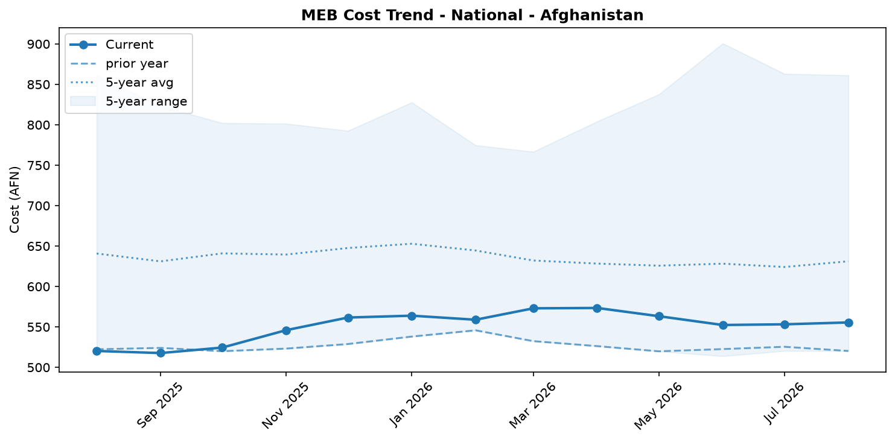
MEB cost trend (National)

Market Overview
In August 2026, the cost of essential food items in Afghanistan continued its upward trend, driven by persistent inflation for key staples. The national average cost of the Primary MEB reference basket configured by the Country Office (MEB) reached 555.54 AFN, marking a slight month-on-month increase of 0.4% and a significant 6.8% rise compared to the same period last year. This increase in the food basket cost contrasts with the general price deflation of -1.6% reported for all goods and services in June 2026, indicating that food prices are a primary concern for household purchasing power.
The main drivers of this food inflation were the rising costs of Wheat flour (low quality) and Oil (cooking), which together constitute over 76% of the MEB's value. The year-on-year price of wheat flour increased by 12.2%, while cooking oil rose by 10.9%. These increases were partially mitigated by a substantial year-on-year price decrease for Pulses (-13.5%) and a monthly drop in the price of sugar. However, the weight of wheat and oil in the food basket ensured an overall cost increase. The market outlook suggests this trend of slight price increases or fragile stability will continue, with significant regional price disparities remaining a key feature of the economic landscape.

Commodity Analysis
An analysis of individual commodity prices reveals the specific pressures driving the overall cost of the food basket. Wheat flour (low quality), the most significant component at 61.5% of the basket's share, saw a modest monthly price increase of 0.5% but a substantial 12.2% rise year-on-year. This trend was mirrored by raw wheat grain, which is not in the basket but rose by 13.8% annually, indicating inflationary pressure throughout the supply chain.
Oil (cooking), another critical item with a 15.1% share, contributed significantly to the monthly cost increase, rising by 3.2% from July 2026 and 10.9% from August 2025. In contrast, Pulses (15.5% share) exerted a strong deflationary pressure, with prices falling 1.2% month-on-month and a notable 13.5% year-on-year. This decrease helped to moderate the overall increase in the food basket's cost. Sugar (7.5% share) also provided some relief, with its price decreasing by 2.6% from the previous month, though it remains 8.2% more expensive than a year ago. Salt, with a negligible share of 0.4%, remained stable month-on-month (-0.1%) but is up 8.6% annually. While not in the monitored MEB, the price of high-quality rice has surged by 25.1% over the past year, highlighting significant long-term inflation for other staple foods.
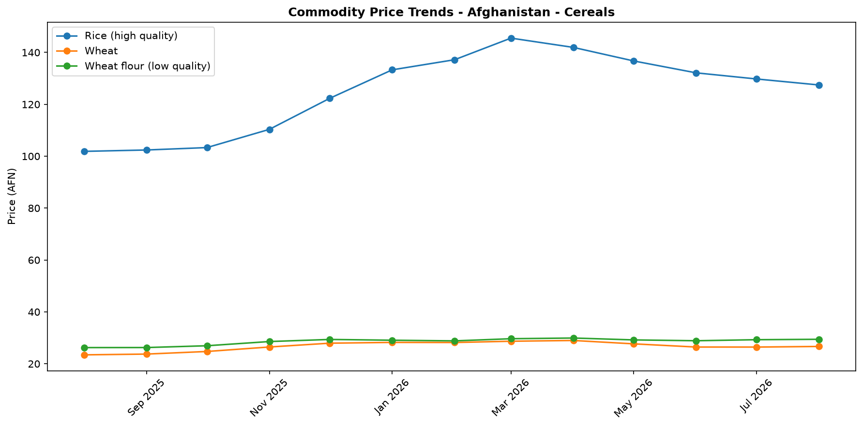
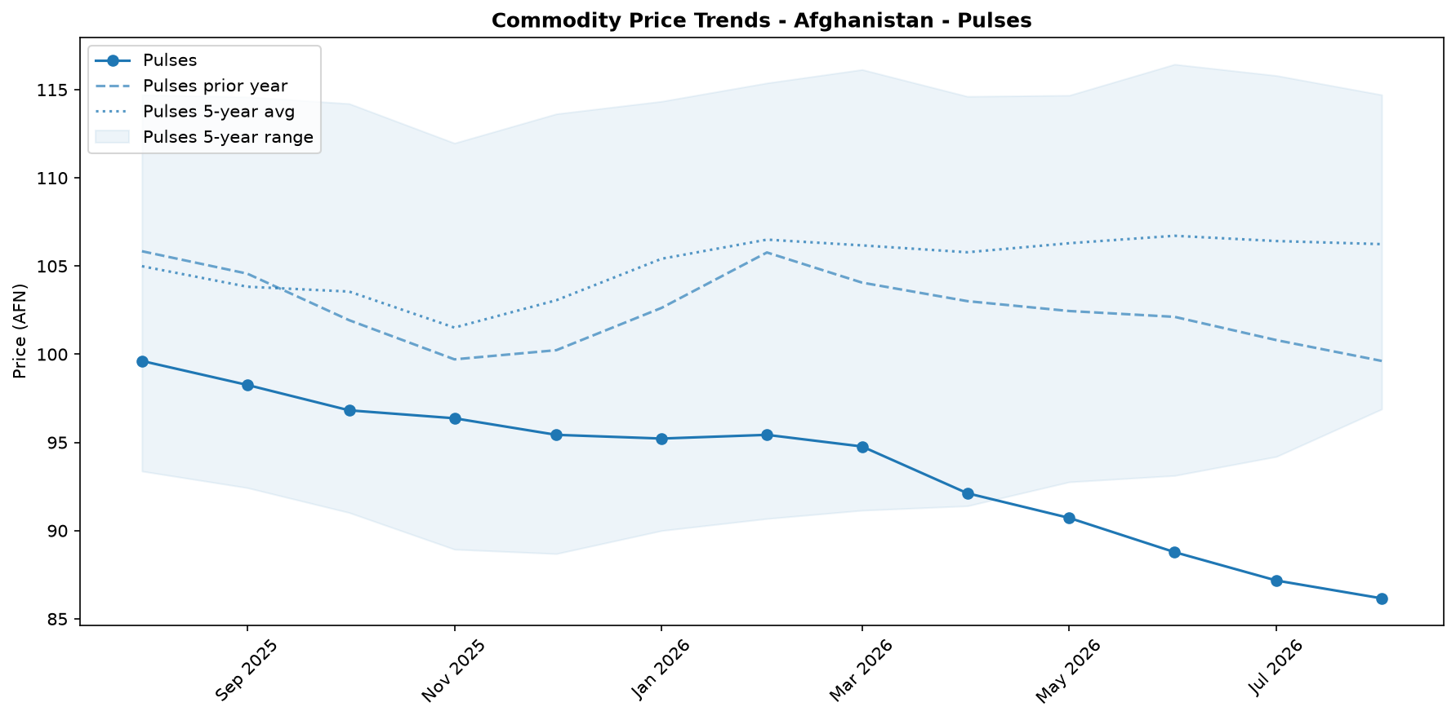
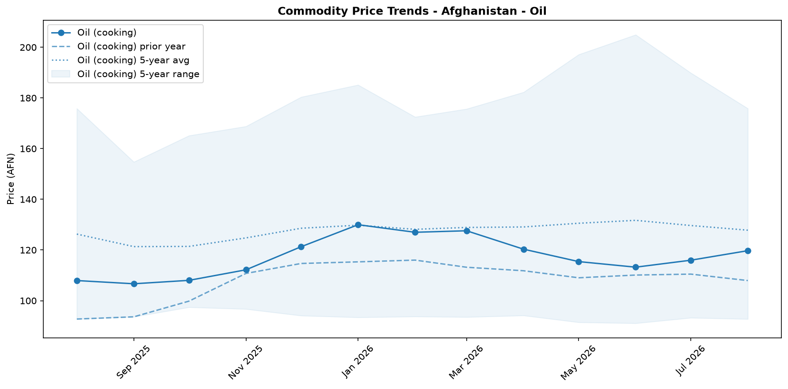
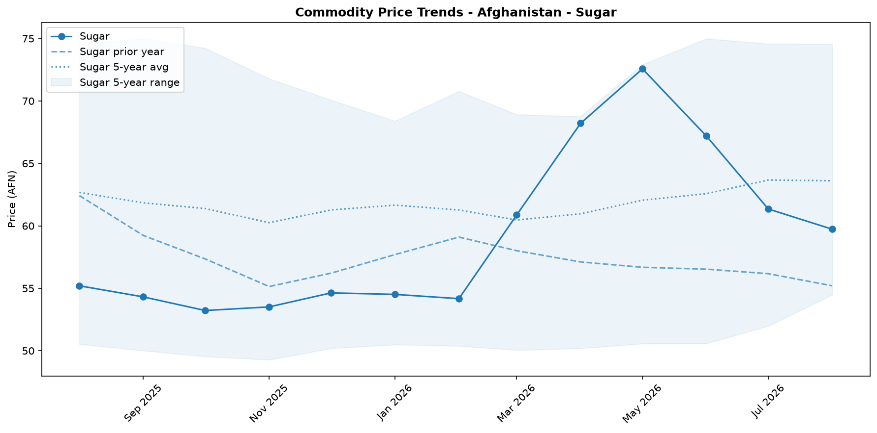
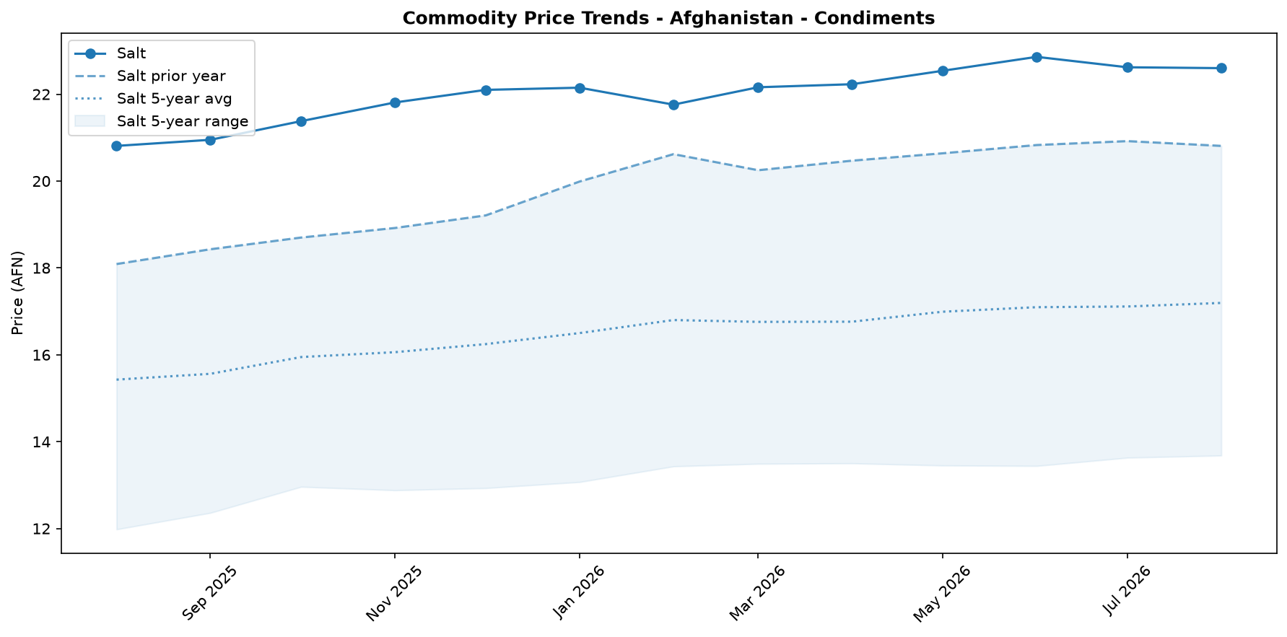

Regional Highlights
Regional markets exhibited significant price volatility in August, with varying trends across provinces. Takhar province saw the sharpest month-on-month increase in the cost of the food basket (+5.7%), followed by Ghazni (+4.4%). In contrast, Ghor experienced the largest monthly decrease, with the basket cost falling by 6.3%. Year-on-year trends also varied widely. Bamyan recorded the highest annual inflation at 15.3%, while Ghor was the only province to see a year-on-year price decline, with its food basket cost decreasing by 6.5% compared to August 2025. The cost of the food basket was highest in Nuristan (649.2 AFN) and Daykundi (641.9 AFN). Conversely, the cost was lowest in Sar-e-pul (499.9 AFN). These disparities highlight the fragmented nature of local market conditions across the country.
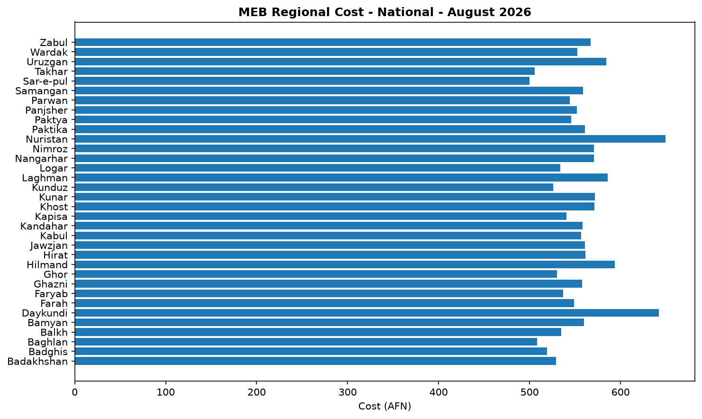

References
- [rw_4227845] ReliefWeb (2026-08-31) The Iran Route: Afghan Mobility, Livelihoods and Return Pressures | DTM Afghanistan Insights Series - Report 1 (August 2026)
https://reliefweb.int/node/4227845
- [rw_4227786] ReliefWeb (2026-08-31) Beyond Short-Term Aid: Financing Durable Solutions for Displaced Afghans | NRC
https://reliefweb.int/node/4227786
- [rw_4227646] ReliefWeb (2026-08-30) One year after the Kunar earthquake, many survivors are still homeless and traumatised
https://reliefweb.int/node/4227646
- [rw_4227534] ReliefWeb (2026-08-28) Data for Afghanistan: Latest Poverty Lines by Afghanistan Provinces, June 2026
https://reliefweb.int/node/4227534
- [rw_4227533] ReliefWeb (2026-08-28) Data for Afghanistan: Afghanistan Consumer Price Index (CPI) Report — June 2026
https://reliefweb.int/node/4227533
- [rw_4227532] ReliefWeb (2026-08-28) Data for Afghanistan: Needs & Monitoring — Provincial Urgency Index, July 2026
https://reliefweb.int/node/4227532
- [rw_4227530] ReliefWeb (2026-08-28) Data for Afghanistan: Afghanistan Food Prices & Food Insecurity Report — July 2026
https://reliefweb.int/node/4227530
- [rw_4227475] ReliefWeb (2026-08-28) Asia and the Pacific: Snapshot of El Niño & Middle East Crisis (as of 28 August 2026)
https://reliefweb.int/node/4227475
- [rw_4227440] ReliefWeb (2026-08-27) Afghanistan: Weekly Market Report: Issue 309: Week 4 - August 2026
https://reliefweb.int/node/4227440
- [rw_4227392] ReliefWeb (2026-08-27) Integrated MHPSS Situation Analysis: Afghanistan - July 2026
https://reliefweb.int/node/4227392
- [seerist_1030049] Seerist (2026-08-31) Heightened contract, regulatory risks to persist despite Taliban’s claims of attracting investment
- [seerist_1029834] Seerist (2026-08-14) Detention of UN personnel underscores heightened security risks posed by Taliban authorities
- [seerist_1029750] Seerist (2026-08-07) Activity by anti-Taliban armed resistance groups to continue but remain contained
- [seerist_1029749] Seerist (2026-08-07) Big Picture series: Regional food security outlook amid conflict-related supply, price shocks
- [seerist_1029631] Seerist (2026-07-29) Middle East and North Africa: Outlook for August 2026
- [seerist_1029534] Seerist (2026-07-23) Slow rescue, relief and repair efforts amid flooding to sustain EXTREME operational risk rating
- [seerist_1029517] Seerist (2026-07-22) Anti-Taliban armed resistance groups to remain unable to mount cohesive offensive
- [seerist_1029250] Seerist (2026-07-02) Drone incursions sustain EXTREME security risk in most regions bordering Afghanistan

